Exercise 16

1. List ids, birth dates, and emails of employees born in April.

SELECT e_id, birth_date, p_email FROM employee_per WHERE MONTH(birth_date) = 4;

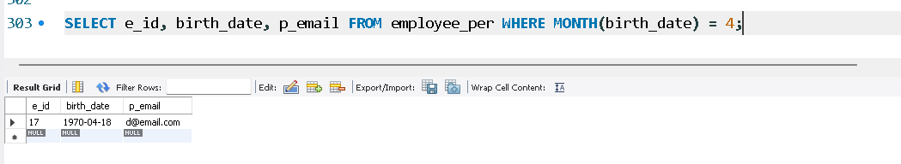

2. Display ids, birth dates, and spouse names of employees born in 1969, sorted by spouse names.

SELECT e_id, birth_date, s_name FROM employee_per WHERE YEAR(birth_date) = 1969 ORDER BY spouse_name;

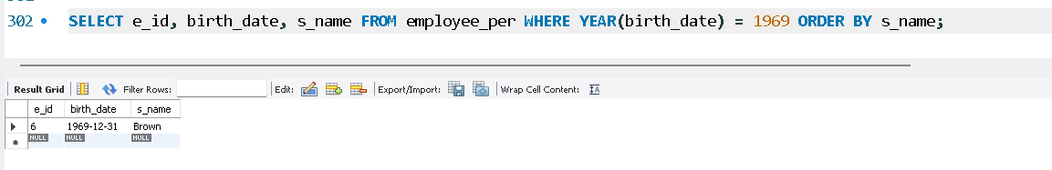

3. List the employee ids for employees born under the current month.

SELECT e_id FROM employee_per WHERE MONTH(birth_date) = MONTH(CURRENT_DATE);

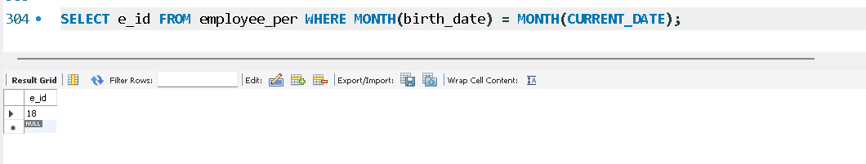

4. How many unique birth years do we have?

SELECT COUNT(DISTINCT YEAR(birth_date)) FROM employee_per;

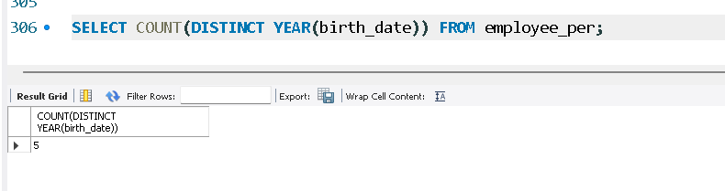

5. Display a list of unique birth years and the number of employees born under each.

SELECT YEAR(birth_date) AS birth_year, COUNT(*) AS emp_count FROM employee_per GROUP BY birth_year;

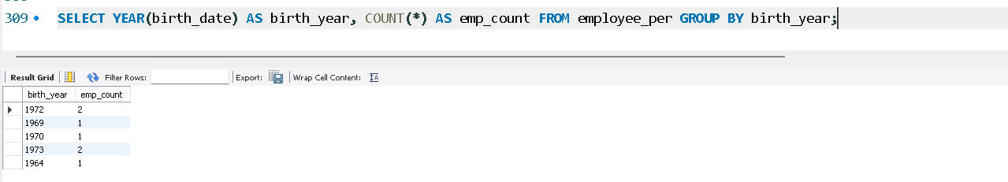

6. How many employees were born under each month? Display should have month names (not numbers) and sorted with the month having the largest number listed first.

SELECT MONTHNAME(birth_date) AS month_name, COUNT(*) AS emp_count

FROM employee_per

GROUP BY month_name

ORDER BY emp_count DESC;

